UNIVERSITY OF MICHIGAN

VISIBLE HUMAN - NEXT GENERATION INTERNET PROJECT

4th Quarter Year 1

Overview Dr. Brian Athey
Knowledge Engineering Dr. Fred Bookstein
Knowledge Engineering Alexander Ade
Pittsburgh Supercomputing Center Arthur Wetzel
Database Development Dr. T. Weymouth, W. Meixner
UIT - Anatomical Sciences Dr. T. Gest

Appendix: Viewgraphs of --
Brian Athey: Year One Wrap-Up
Carl Berger: UIT Year One
T. Weymouth, W. Meixner - Database Development

Knowledge Engineering Team

Fourth Quarterly/First Annual Report

(.) Personnel

Principal personnel on this subproject are Fred Bookstein and William D. K. Green, University of Michigan, and Arthur Wetzel, PSC. Alex Ade, from the Networking subgroup, has put substantial effort into this thrust as well. During the quarter, two additional collaborators, Bradley Smith and Daniel B. Karron, joined the group at the University of Michigan (Smith physically, Karron virtually).

(.) Q4Y1 accomplishments

The principal MILESTONE of this fourth quarter is an extended version of Edgewarp that requests "chads" (cubelets) of data from the server whenever slice contents are required outside of the current resident list. It is therefore capable of displaying one or more multiple-gigabyte volumes at adequate speed using only 128 megabytes of main memory. This upgrade required substantial code development both at the PSC site (see under PSC in this Progress Report) and in the Edgewarp program itself. As demonstrated to Don Jenkins on 12/1/00, the server-client relationship is a superset of the standard Edgewarp interface, whereby a copy of Eve at eightfold reduced resolution is always resident, to be overlaid at fourfold reduction, twofold reduction, or full scale as the user determines. As currently implemented, this Edgewarp keeps a list of cubelets not yet rendered, filled in from the undersampled image so that the slice window is never black within the volume actually occupied by Eve's body in reference to the slice position specified. (In other words, the image boundary is _always_ ice blue, rather than the black of the zero voxel.) As the server sends these, packet by packet (about two hundred per second, in the 12/1 demonstration), the slice window is updated to show successively greater detail. This extension of Edgewarp is designed for the context of our "filmstrips" -- strings of linearly interpolated pairs of Edgewarp slice poses -- as delivered in Q3. In operation, it follows closely spaced sequences of slices generated by the animation engine, filling in their chads as fast as it can.
Another DELIVERABLE for the Q4 period was a "first stage navigation interface." The filmstrips of Q3 did not serve this purpose, owing to their evident nonsmoothness wherever the filmmaker would change the style (e.g., rotate, translate, twist) of the pencil of planes being illustrated. In the course of Q4 we discovered a surprisingly powerful extension of this facility. As demonstrated on 12/1, when the pencil of planes in the filmstrip is smoothed by a moving Gaussian window, independently parameter by parameter for all 13 of its parameters (position, matrix-encoded orientation, scale), the resulting sequence of slices, running at 10 Hz on the workstation screen, adequately simulates smooth motion. MPEG coding/decoding seems not to be required, unless it proves necessary for throughput at the server end during the scaling up to multiple users.
The current Edgewarp release has a facility for outputting individual fully detailed screen images for postprocessing, by hand or by program, in order to supply annotations such as labels. At the 12/1 meeting Dr. Bradley Smith demonstrated a prototype of that annotation in which the labeling information smoothly fades in and out over subsequences of a filmstrip, whereas the extent of a labelled feature was indicated by line style of the leader (for regions, a single line, pointing at the center; for extended arcs, a pair of lines pointing along the extent). These supplement the existing Edgewarp facility for labelling the individual landmark points, the points that are used at present to construct the geometry of keyframes underlying the filmstrip.

A separate software development effort by Mr. Alex Ade uses Java programming in a web-based environment (see Mr. Ade's report). A prototype of this WWW facility was demonstrated at the 12/1 meeting, including prototype links to databases of surface renderings and text information.

(.) Q1Y2 plans

The original proposal of 1999 assigns our team the Q1Y2 task of "provisional handling of surface traverses". As it happens, that has already been done in the course of the demonstration filmstrip (Eve's vaginal tract) displayed on 12/1. The standard Edgewarp controls proved sufficient to traverse this particular surface (actually, a flattened tube, that is, a double surface) along a series of principal normal planes to a curve upon it equivalent to a smoothed planned path along the surface linking landmark points (introitus, ostium, bottom of the pouch of Douglas).
It follows that the segmentation and navigation goals of this project, which had previously been linked in a critical path, can be decoupled. Using the current release of Edgewarp, together with landmark points located by hand, we can construct useful traverses of Eve's pelvic region without having to wait upon the segmentation geometries generated by other software initiatives under this contract. When those segmentations are available they will be added to the Edgewarp world as semitransparent objects in the left-hand (world) window, sections of same in the right-hand window; but the construction of filmstrips need not wait on the availability of these visualizations.
Because the Y2Q1 deliverable need not wait for segmented surfaces, it can be upgraded from "provisional handling of surface traverse" to actual demonstrations of surface traverse. What will be prototyped is the semiautomatic affixing of labels and rendered surfaces, as available, to those navigations. (Labelling of points is already available, but there is no data base of these at present.) Also intended for inclusion in the Y1Q2 release of Edgewarp are features for the editing of filmstrips to make them more flexible and informative: features for pauses, branches, and optional detours. The smoothing of the filmstrips by Gaussian windowing parameterwise will be moved from its present context (an external statistical processing package) directly inside Edgewarp. The WWW implementation of an Edgewarp-like interface by Mr. Ade, which prototypes guide features and label retrieval, will be considered for duplication within Edgewarp once the associated data base structures have stabilized. It is expected that the generation and editing of surface segmentations will be via software overseen by Dr. Karron, and the graphics of attaching labels to the appearance of these databases within the main Edgewarp windows will be the responsibility of Bradley Smith, our visualization expert. In conjunction with the User Interaction Team and with Dr. Smith, these filmstrips will be polished for commentary by our test groups and by other members of the NGIVH consortium at Stanford and elsewhere. We will share our expertise in filmstrip construction with these other sites, in addition (of course) to successive releases of Edgewarp as its modes of function accrue.

(.) A retrospective view of contract year 1

One way of reviewing the first year of this contract is to note the three different versions of the Edgewarp program. The first of these, for Y1Q1, incorporated 24-bit color.
A second, for Y1Q3, incorporated continuously interpolated series of slice positions between arbitrary endpoints, not only those linked by one of the lowlevel functionalities (translate, rotate, rescale). The third, for Y1Q4, incorporates access to the server via dynamic memory management. The first two of these have been released simultaneously for a high-end Unix workstation (SGI) and a more typical Linux based PC with a state-of-the-art texture mapping card (NVidia), and the third will be released in the same dual manner in due course.
The current client-server relationship seems more satisfactory than the version demonstrated transcontinentally in August using the Q3 release of Edgewarp. In that demonstration, entire Edgewarp screen images were generated on the server and then shipped to the client as large files for display. The system ran at about 4 frames per second from Ann Arbor to San Jose when end-to-end locking was disabled. The new demonstration drives the same client (an SGI Indigo) at full frame rates, subject to the filling-in of areas of interest over a second or so. Since then, the server has been shifted from the Onyx of August to the ES40 node used in December, so that all the load of rendering now resides on the client. Nevertheless the corresponding increase in throughput is very satisfying. Within the spectrum of potential clients that has governed our thinking throughout this year, the latest version of Edgewarp is by far the most sophisticated. To cover the more all-inclusive WWW domain (for instance, access from high schools or four-year colleges), we have proceeded in parallel with development of the web-based HTTP interface by Mr. Ade.
The design of pencils for filmstrips independent of segmented surface geometry, leading to the 12/1 demonstration that smoothing of pencils can substitute for smoothing of segmented surfaces, has occupied us throughout this first contract year. Our success in this endeavor permits the decoupling of navigation from segmentation that will lead to speedier progress in both domains over the course of Y2.
Other highlights pertinent to the efforts of the Knowledge Engineering team in this first year -- establishment of the highly structured archive of Eve at PSC, and optimal tuning of the network connectivity for the Q3 release of Edgewarp -- are reviewed elsewhere in this progress report.

User Interface Design and Implementation for the World-Wide-Web

Alex Ade

Description

I have combined the v2.0 browser presented last quarter with a web-based volume visualization engine to produce a prototype software framework, demonstrated at the fourth quarter meeting. Data are sent to the engine via the world-wide-web in response to requests from a three-dimensional selection interface. The selection window shows the 3 cardinal views through the Visible Human dataset, while allowing the user to interactively add 3D models to the scene. Shaded models show 3D relationships and serve as landmarks to aid the user in selecting a volume of interest. A semi-transparent cube in the scene is used to select data for download. Once loaded, the engine is capable of using both arbitrary slicing and “ray-tracing” visualization techniques. Slicing and “ray-tracing” are done in real-time. The user may also interactively add 3D models to the volume so that the 3D objects are shown with a 2D slice that “cuts” around them. Using XML, the browser interacts with the anatomical database to display multimedia information including text, imagery, movies, sound, and models. The framework demonstrates that sophisticated visualization techniques can be realized in a pure web-based environment.

Problems

A problem this quarter has been in the preparation of models. We’ve discovered that the Surfdriver software package produces non-uniform coordinates within a family of models.

Resolution of Problems

Different contouring and model making software will be used.

Goals for Fifth Quarter

During the upcoming quarter, I intend to enhance the functionality of each module within the application framework. In the selection window, I will add user configurable transparency of 3D models by a combination of selection and slider control. Database interactivity will be improved by displaying relational information with “scrollable” navigation. A caching mechanism will ensure quick downloads and display of recently accessed information. The volume visualization engine will feature user configurable look-up-tables so that one may “see” further into the cube.

I will begin developing a bridge to the PSC cubelet data server that is optimized for Java so that various cube sizes and resolutions may be loaded into the application.

Finally, I will extend the software to allow stereo viewing. Stereo shutter glasses, an emitter, and an appropriate graphics card will be required. Stereo will improve the experience of navigating within a three-dimensional world. Spatial relationships between models will be more realistic.

Fifth Quarter Needs

For the fifth quarter, I will require more consistent content from the Visible Human dataset. Higher quality models with accurately texture-mapped surfaces will enhance the educational experience.

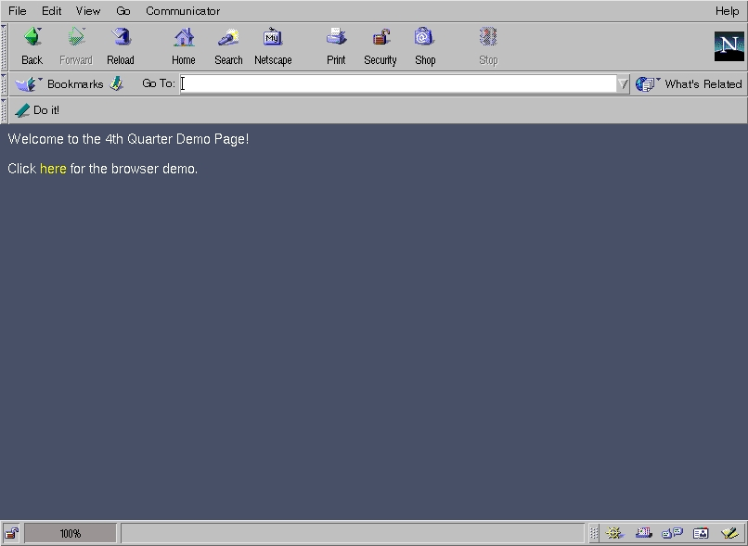

Figure 1: Web based launching mechanism for the software framework. The entire software package can be launched from any standard web browser

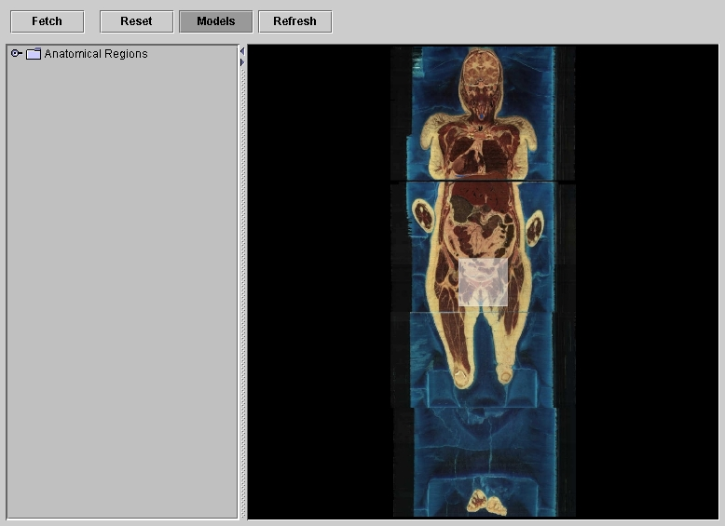

Figure 2: 3D navigational selection window. Three cardinal planes are shown with the semi-transparent "selection cube". A hierarchical listing of anatomical objects is available.

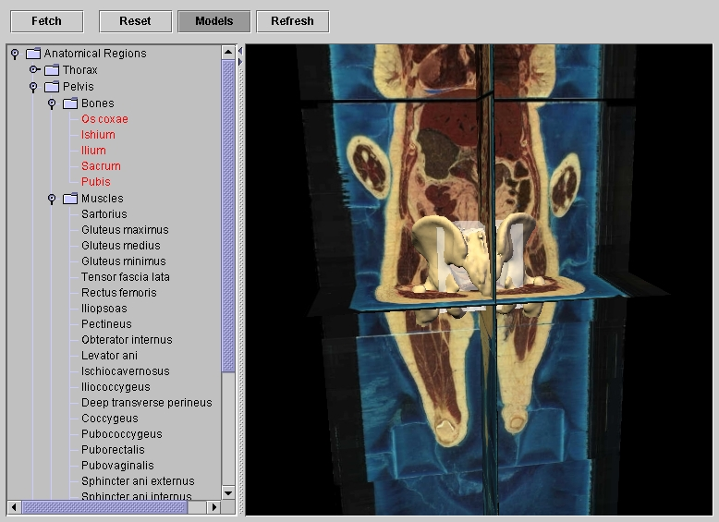

Figure 3: 3D selection window with the pelvis model loaded.
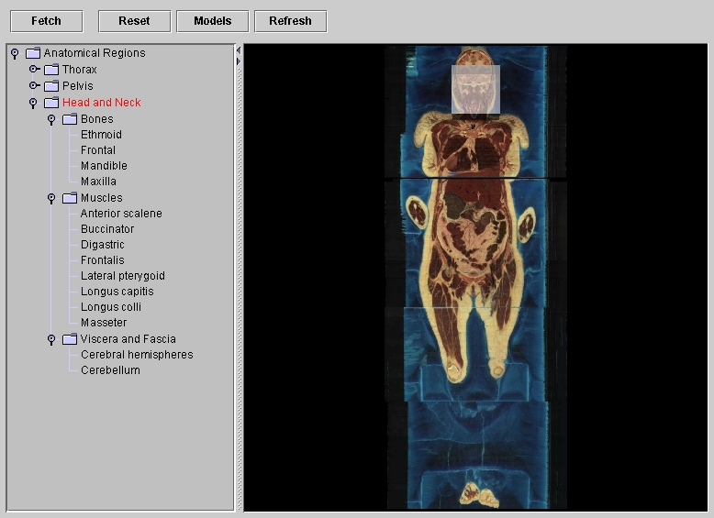

Figure 4: The "selection cube" is used to define a volume in the Head and Neck region.
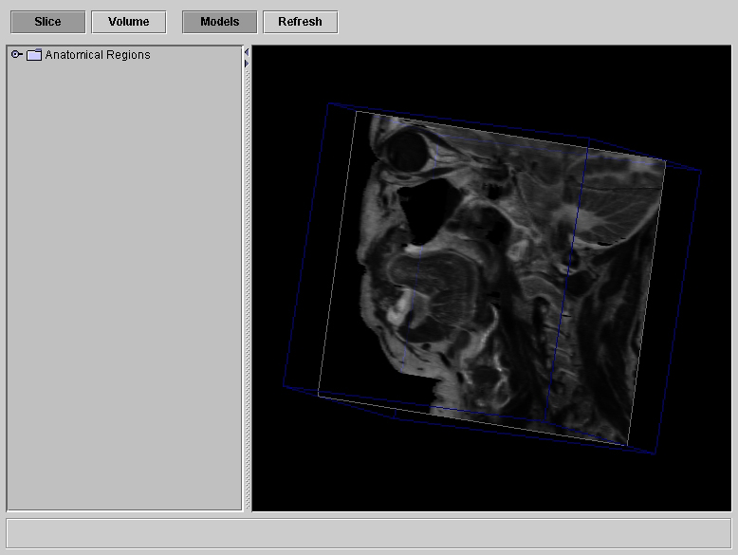

Figure 5: A cube of loaded into the volume visualization engine toggled into "arbitrary slice" mode.
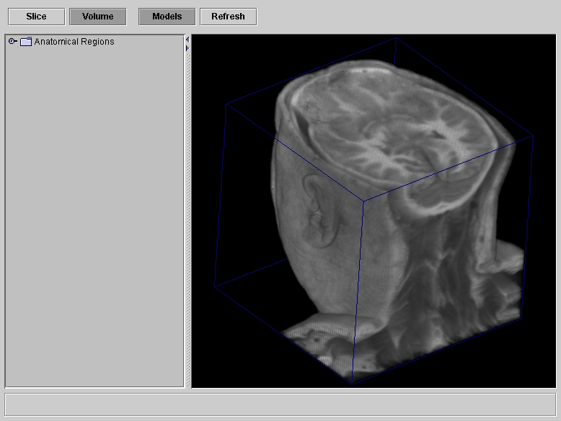

Figure 6: The volume visualization engine switched into "ray-tracing" mode.
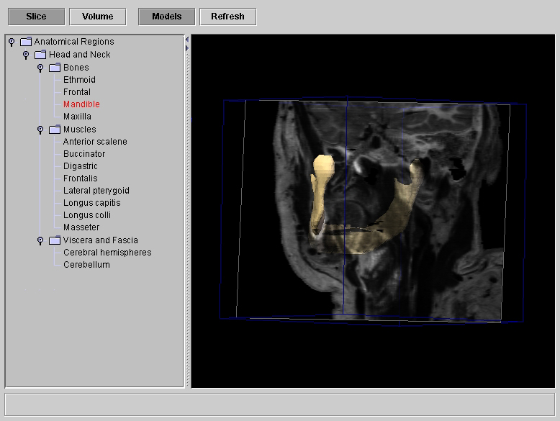

Figure 7: 3D model of the mandible embedded into the volume of data. The engine is toggled into "arbitrary slice" mode.
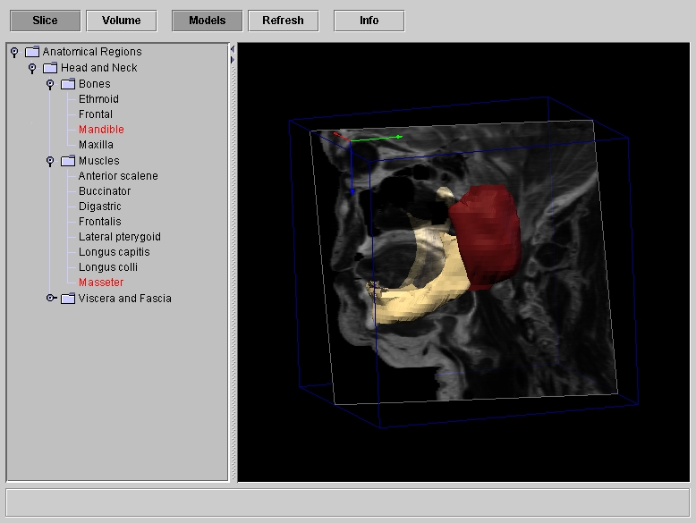

Figure 8: Mandible and Masseter muscle embedded into the cube of data.
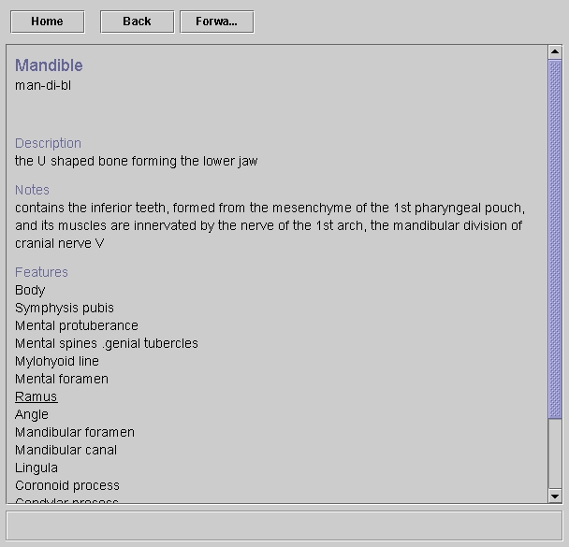

Figure 9: Mandible selected from hierarchical listing. Query sent to database which returns XML formatted data. SML parsed and displayed in browser.

Fourth Quarter PSC Visible Human Subcontract Status Report

1) Description of progress towards/completion of quarterly milestones & deliverables.

The major areas of progress this quarter were targeted to demonstrating navigation over the entire volume of the Visible Female using a client server interface between Edgewarp and a central volumetric data server. This was accomplished using a Compaq ES-40 based computer at PSC's Westinghouse machine room as the server in conjunction with the latest network enabled version of Edgewarp as the client. Communication was handled by a socket based protocol using TCP/IP for retrieving small 8*8*8 voxel cubes of data. (We are currently calling an 8*8*8 cube a "chad" and this is synonymous with what we have sometimes called a "microcube". A "cubelet" is a larger 64*64*64 cube.)

As reported in the previous quarter, the ES-40 we are purchasing (it is officially still on loan from Compaq) is a 4 processor Alpha 21264 machine with 4Gbytes of memory. Other than CPU clock speed it is identical to nodes of the PSC Terascale. This machine, "vh.psc.edu", had previously been used for Terascale testing and ran Compaq Tru64 Unix as the OS. We have replaced that OS by Linux and have installed 200Gbytes of disk to support the Visible Human work. The switch to Linux was needed to support some of the planned low-level network aspects and allow for a future volumetric data page fault driver.

The server is being configured to support many simultaneous users and testing of multi-user capability will be a primary focus over coming weeks. We are working closely with Matt Mathis, who leads the PSC Web100 project and is part of our subcontract team, to get good measurements of network activity and to make adjustments for maximizing performance. Anjana Kar is also on both project teams. As part of the performance monitoring and tuning effort we have installed the set of Web100 modifications to the networking portions of the Linux kernel. (See http://www.web100.org/) In addition, NetLogger from LBL is being set up to generate precisely timed client and server event logging. (see http://www-didc.lbl.gov/NetLogger/).

During the period from Dec 1 to Dec 15 we have already had a few instances of simultaneous server access but the majority has been one user at a time. Over this period we have seen 500 client connection sessions and delivered 3.5Gbytes of data in the form of 2.3M chads. (Note: one Edgewarp user session can involve several different connection sessions) Over 400 of these sessions have been from the Michigan campus and particularly the prolific work by Fred Bookstein in testing the facility and developing filmstrips. Fred's office location is 9 network hops and 20ms trip time away from the server. While working on filmstrip development his connections have reached 50,000 to 90,000 chads and 100Mbytes per session. We have found that the current uncompressed data delivery is adequate to support single user operation at speeds on the order of 2.5Mbits/sec. The current service to Michigan is running at 4.5Mbits/sec and we see 6Mbits/sec to our PSC offices. Bill Green has also been able to operate from Bellingham Washington despite his longer network distance of 19 hops and 170ms trip time.

As a result of this level of server traffic as well as a similar amount of testing from other test codes at PSC we believe the underlying network interface is now stable and reliable. It has been running without problems or restarts for 10 continuous days. This was not initially the case as we had several false starts which led to client and/or server hangs and crashes. These have been fixed in the current uncompressed service. Because of the earlier problems we are investigating several issues which need to be fixed prior to the release of
the compressed data protocol.

Currently the server is delivering data from the bounding box of the RGB Visible Female which includes all of the body except for part of the left index finger. This box is 1664*896*5180 voxels occupying 23Gbytes as compared to the entire block of ice which is 39Gbytes. The data is maintained as a resolution hierarchy, that is also the basis for the wavelet compression mechanism, ranging from full scale and at reductions of 2, 4, 8 and 16. The current Edgewarp application uses scales 1, 2 and 4 but keeps a copy of the scaled by 8 (i.e. volumetrically 1/512th of the data) to provide instant startup at the client.

Compressed data representation has progressed this quarter and is nearly ready for release after revisions to address problems identified during the uncompressed network service. Decompression code will be integrated into Edgewarp but does not change the essential nature of the exchange of chad requests and their delivery over the network. Compression is a key part of the strategy for scaling up to the 40 simultaneous user goal. Even a compression factor of ~15:1 is enough to reach the 40 seat target from a single server for clients which can perform real time decompression. Indications are that we should be able to reach compression ratios considerably better than 15:1 with little visual effect. During navigation and other time critical actions the client will retrieve a slightly lossy rendition of the data but can also access a lossless replacement as needed. Due to the data's inherent SNR of ~80:1 lossless compression is limited to about a 3:1 ratio.

Portions of the compression and related work along with a brief overview of the entire project were presented at the October VHP conference. A copy of the conference paper submission as it will be on the conference CDROM can be viewed on the web from "http://www.psc.edu/~awetzel/vhpconf3/". The file "WETZEL.HTM" is the starting page from the CDROM version and "fullpaper.html" produces a single linearized version without the additional button links that are used for the CDROM. The directory also includes "wetzel_vhp3.ppt" which was the power point presentation file.

1A) Highlights from year 1

A great deal of effort in the first half of the year went to providing data services to the rest of the project team. To do this we built a web-based service from a Compaq XP-1000 running Linux and accessed by the name "vhserv.psc:8000". Initially this provided Visible Female slice retrieval from pre-constructed images over the entire data volume for each of the three cardinal axes. This was progressively extended to allow retrieval of arbitrary planes at any orientation and location and scaled at any integer reduction and delivered in either compressed JPEG or uncompressed PPM form.

The data for arbitrary slice delivery was stored on disk as 64*64*64 cubelets to allow retrieval at any orientation and also to prototype volume data delivery over the network. We were able to demonstrate retrieval of 256*256*256 cubes of data for interactive use at Edgewarp clients. In this facility we used "http" as the protocol which worked well for the retrieval of large chunks of data driven by occasional client side requests. Although this allowed users to work with any part of the data it was not a seamless real time navigation. In order to achieve a real interactive connection between the client and server we needed to support large numbers of requests for relatively small sized pieces of data. One of the important findings from our experiments was that "http" was not an appropriate protocol to retrieve volumetric data for use by a demanding interactive application such as Edgewarp even with the use of persistent connections.

A number of experimental web interfaces were developed and tested on "vhserv" which also was the primary work machine for developing and testing compression methods and providing network tests. The most convenient of the web interfaces is a synchronized browser which presents all three cardinal plane views centered on the region of the user's mouse click selection.

We were able to use "vhserv" and also PSC's SGI Onyx, "trinity", which are located together in the PSC graphics lab to support a number of local and remote demonstrations. Using VNC, Netmeeting and SGImeeting we were able to host several sessions with Fred Bookstein as a remote operator and presenter for collaboratory discussions with researchers from the NCI and at the University of Pittsburgh Medical Center. These demonstrations showed the value of the SGImeeting/Netmeeting model for using shared application controls but also the limitations of the underlying network protocol for highly interactive applications such as Edgewarp. This was also useful as part of the ongoing cooperation between this project and PSC's NCRR supported collaboratory tools project.

As the year ended we were able to show client server navigation of the entire Visible Female RGB dataset with variable scales of view and arbitrary orientation and position. This brought together the capabilities of Edgewarp, networking and hierarchical data representation running with a simple protocol oriented to interactively deliver small chunks of data. This method avoided the limitations we had seen with both the Netmeeting and http protocols for our application and reinforces the value of progressive hierarchical delivery of volume data rather than finished image slices from the server. This provides a layer of isolation between the user and delays due to network latency because the client can continue with full frame rate user interaction using degraded image quality which is much easier to tolerate compared with a jerky display at a uniform visual quality.

2) Problems encountered during this quarter.

There was some delay in completing tests using the ES-40 for other projects before it was turned over to us and had its disk upgrade. After the ES-40 was available we also had unexpected difficulties getting Linux installed and operational. The install process would start OK but then hang.

We continue to find that network bandwidth is not up to expectations. Data delivery from the server to the world outside of PSC still tops out around 10Mbits/sec, and even inside PSC the rates from the ES-40 to other machines levels off at 50Mbits/sec. This is half the rate of the default 100Mbits/sec network card. We have tried to do better using a Gigabit network card on loan from UMich but have not been able to get any higher data rate from it.

We also had some stability problems with the initial version of volume server to Edgewarp network interface and issues of complexity in the connection protocol.

The biggest problems of the quarter were in nontechnical areas - particularly staffing and contract issues. It took considerably longer than anticipated to complete the hiring process for an additional programmer. There was also a problem with the CMU legal office in signing off on the Y2K requirements of the contract as required by NLM.

3) Resolution of problems.

For unknown reasons, the installation of RedHat Linux on the ES-40 required a graphics card even though that is not needed for its server application. We worked around this by borrowing one from another machine after the cost of several days tracking down the nature of the problem.

We continue to investigate network infrastructure limitations in cooperation with the PSC operations staff. This is not something that we can solve just within the context of the current project but we will be taking advantage of the general upgrades which are coming out of the Terascale installation. We are looking at routing options in the short term to help us take better advantage of the Gigabit network card we have borrowed from UMich.

In order to get past the difficulties with remote operation between Edgewarp and the server we had to back off from the more complex protocol to a minimal "chad" service. This let us concentrate more directly on the stability problem and the basic Edgewarp to server data exchange. Programming on both the server and client ends have solved this and both are now running reliably. We are revising aspects of the expanded protocol and compression in light of what we have learned.

We have been able to hire Stuart Pomerantz as an OpenGl and data structures implementation programmer. Stuart officially begins work on Dec 18 but was able to come along to the 4th quarter meeting in Ann Arbor to maximize his early exposure to the project. He comes to us from the University of Pittsburgh Math Department where he was systems administrator and brings a lot of skill in the operations of Linux computers in addition to programming talent.

After direct discussion between the CMU legal people and the NLM, CMU has signed off on the contract including the Y2K issue.

4) Goals for the next quarter & action plan for their completion

We will be building on the initial operation of the server to release a better protocol to support reliable delivery of compressed volumetric data to Edgewarp and other clients as well as finished slice images to clients which are not able to do their own decompression. Although we now have actual measurements of an acceptable data rate needed to support Edgewarp we will be expanding on that by exercising multiple simultaneous users doing different tasks and also the effects and proper settings for compression levels and the effects that multiple users have on one another.

This work will be done both over the remote connections from PSC to UMich but also in the local PSC facilities and will be drawing heavily on the Web100 instrumentation and tuning facilities with additional help from NetLogger Tests will also be started to determine the role for QOS as an adjunct to network tuning as a way to provide the most equitable service to many simultaneous users. Some part of this work will involve the user interface team to help us judge acceptable levels of compression and frame rates.

Although the current client server work with Edgewarp has been using the RGB Visible Female data, we plan to provide the same access to the Visible Male data and the CT/MRI data. In addition to simply building and loading the data structures this relies on a protocol for dataset selection from the user interface and presents the issue of noncubic voxels. We are working on a compatible way to provide that capability to Edgewarp and other potential clients and will prototype this during the new quarter.

The addition of another implementation programmer will let us move ahead with releasing work that has only been in early prototype stage. This includes a user interface for nonlinear slice delivery, such as the spline of the spine example, and volumetric raycasted projections.

As organ and tissue surface segmentation data becomes available we will be including surface retrieval and the generation of illuminated and textured surface viewing into the protocol. We are also planning to take advantage of local expertise in the use of Renderman as a way to produce very high quality stills and movies of specific parts of the dataset. We are still investigating whether this capability can be used to generate dynamic views on the fly as users navigate or if it can only be used for predetermined views.

5) Next quarter needs

During the next quarter we still anticipate some staff level adjustment as we revise the portions of work being done by the various project groups and increased interaction with the networking group at PSC. We also will be finalizing equipment purchases and determining what is needed in the line of networking changes as WEC to take full advantage of the capacity of the ES-40 server.

Database Development: 4th Quarter, Year 1

The annotations of the visible human project will require a database of associated information. We are calling this the Visible Human Knowledge Base. During this last quarter, we did extensive prototyping, trying out the encoding of various relationships and representations to gain an understanding of the type of information that we will need.
We developed a three tier design:

- The layer closest to the Visible Human data will consist of the raw data (voxels of image data,
CT, MR etc.), segmentations with labeling, and 3D model-like surface descriptions
- The layer attached to that will be a semantic network of medical terms and their relationships.
This is the layer upon which we have spend the most time doing detailed analysis. Just in
prototyping the head and abdomen we have identified hundreds of different terms and dozens
of relationships
- The third layer is the layer of annotations: descriptive texts, movies, illustrations, tours of
data, etc. Little is know about the needs of this layer, except that it will be associated with
terms in the semantic network.

During this quarter, we have developed a series of prototypes to test this design (and in their failure, extend the design). This investigation continues.
The present database has been constructed to present information which will be of most use to first and second year medical/dental students, as well as lower educational levels (see Appendix 2 for viewgraphs). Modification of Dr. Gest's anatomy tables (parsing for semantic relationships, formal representations of implied whole/part systems) has begun. These modifications will improve maneuverability within the database.
Visible female sections which have been segmented and labeled by the anatomy team have been translated into a pixel-to-label, run-length-encoded format for compactness, and linking to the modified tables has been demonstrated.

During the next quarter, we plan to build a working example of the three tier design for a subset of the database in a selected target area. The perineum has been selected by the User Interface Team, and this also will be our target area.

Group: UIT CONTENT/LABELING, ANATOMICAL SCIENCES

Progress & Projection Report

In terms of content generation in Medical Education, much has been done regarding the development and deployment of streaming QuickTime movies for use and in the testing of student response to digital media. Initial media covers the first fifteen gross anatomy laboratory sessions (superficial back through pelvis). The remaining gross anatomy sessions are without digital media. The movies are being streamed via the Intranet and have been compressed with high-speed connection codecs since the content requires a fine degree of detail in viewing. A five-question survey of student responses indicates this digital media is considered a vast improvement over the more conventional learning tools for gross anatomy. Student response also indicates a need for more interactivity connected with the movies for navigation and clarification (in terms of labeling detail).

The need for navigation and clarification has also been under study this quarter. Independent modules have been developed (Female Pelvis and Dissection 24 Head & Neck Anatomy) in which navigation has been provided by incorporating Flash technology in the form of labeled buttons. Text and animations have been incorporated into the modules to emphasize important concepts and structures being covered in the movies. The software required to create these modules are publicly available: Adobe GoLive, Adobe LiveMotion, Macromedia Flash, Final Cut Pro, and QuickTime Pro. The Dissection 24 Head & Neck Anatomy module is currently slated for student testing and response by the School of Dentistry, who is interested in a collaboration with this unit to develop a series of Head & Neck Dissection review modules.

In regard to the content for linkage with the Edgewarp module currently under development, future projects will see the movement away from the self-contained movie modules. The use of Flash technology as the main navigational driver limits the use of other transitional elements out of the movies (e.g. calling a movie from within a movie). To provide for the greatest flexibility of digital components and to allow for maximum use of the Edgewarp module in a web environment, content will be tagged as html and composed using SMIL (Synchronized Multimedia Integrated Language). This will also allow for flexibility in the integration of compositions, within the UIT Anatomy Educational software under development.

Anatomy content will also populate an Oracle database for future use and study of browsing systems.

Labeling in the Visible Human Project has been curtailed over the last quarter due to teaching obligations in the Division of Anatomical Sciences. An open window of opportunity starting in January will see labeling become the priority once more. With the addition of hard drives to store the Visible Human sections, the obstacle of slow rates of download will be removed and progress is expected to be steady through the quarter.

Year 1 Accomplishments

Team organization & task assignment

Bone - Burkel
Muscle - Kim
Vessels - Cortright
Viscera - T. Fischer
Nerves, misc. - Gest
Editorial review - L. Fisher

Established labeling technique

Photoshop layers, cut out from common background
Prevents over- or under-labeling
IN USE/ NOT IN USE folders
Prevents two people from cutting from same background
Harvested and organized pelvis sections for labeling
Completed labeling for abdomen of female dataset
Completed labeling of muscles & bones in female pelvis (1800a-1920a)
Labeling in progress for viscera, vessels, nerves, misc.

Related projects

Geri Pelok joined courseware development team
Set up streaming video server
Developed interactive movie format utilizing Macromedia’s Flash
Developed streaming QuickTime movies of dissections
Back, thorax, abdomen & pelvis

Problems

Labeling team changes
Fischer & Cortright leave project
Stein accepts position
One position empty (since 6/00)
Network woes
speed & storage space
Personnel changes
need to attract another anatomist to project
need more hands & eyes involved in labeling

Goals for 1st quarter, Y2

Complete labeling for pelvis of female dataset

Initiate and complete labeling for thorax of the female dataset
Related projects:
streaming movies of all dissections
populating of movie clip database
educational, interactive module prototyping

