THE UNIVERSITY OF MICHIGAN VISIBLE HUMAN PROJECT (UMVHP)

QUARTERLY PROGRESS REPORT: Y3Q2






Brian D. Athey, Ph.D.
Asst. Professor
Director, UMVHP
July 9, 2002

UMVHP: THIRD YEAR QUARTER TWO REPORT
TABLE OF CONTENTS

Knowledge Engineering Team Report............ 03
PSC Status Report........................................... 07
Anatomy Report.............................................. 10
G. Henny Report............................................. 11
iVoxel Browser............................................... 13

Y3Q2 REPORT, KNOWLEDGE ENGINEERING TEAM
June 24, 2002

ACCOMPLISHMENTS OF THE QUARTER JUST ENDED

The principal accomplishments pertinent to our Knowledge Engineering theme in the quarter just ended were as follows.

1. Intensified dissemination

a. One principal goal of the work under this contract has always been diffusion of the Edgewarp visualization approach to a larger community of users than our small circle. To that end, the User's Manual mentioned in the preceding quarterly report has been updated and uploaded in a selfconsistent FTP directory complete with test volumes, the EWSH save files that access those volumes, and the EWSH manipulations that display the power of the system in interaction with those volumes. For instance, in addition to the volume of Eve, in two formats, there is a tiny test volume, 11 by 11 by 11 voxels, that, when correctly processed in EWSH, spells out an encrypted message "EW".

b. We have modified one of EWSH's principal tools, the "pencil" command, to more easily sustain the type of diagram that new users of the system have found particularly attractive: a "still picture" presenting several keyframes of a filmstrip in one simultaneous view. EWSH pencils have been published on the cover of the SIAM (Society for Industrial and Applied Mathematics) News for May, illustrating an article on the session devoted to Eve and EWSH at their March annual meeting, and have appeared twice in The New Anatomist, the subjournal of The Anatomical Record concerned with computational techniques: once in the April issue, illustrating an article on the teaching of embryology, and (this time in color) on the cover of the June issue, showing an analytically powerful series of planes that together visualize Eve's corpus callosum in a surprisingly effective manner. What is particularly satisfying about this publication is that Eve is not the subject of the associated primary research paper at all. Instead, the NGIVH software is being used to explain the kind of visualization that was, in the event, applied to a different sort of resource entirely (namely, 180 ordinary MR scans). This typifies the "imaginative" application of EWSH -- use of EWSH to show the meaning of other visualizations -- right alongside explicit visualization of Eve herself.

c. A module has been entered into EWSH that permits nearly full control of one copy by another that is elsewhere on the Net. The module was demonstrated in April and the User's Manual updated accordingly. Arbitrarily many copies of EWSH can be controlled from one master site because what is transmitted is only the contents of .sav files (mainly slice geometry parameters), while the volume being accessed remains under the management of the slave EWSH copy, which will either retrieve it from the PSC server or access it from the locally stored version we detailed in the previous Progress Report.

2. Modifications in the deformation grid module

The EWSH program package has always contained a deformation grid utility that visualizes the deformation of space (technically a thin-plate spline) most smoothly matching two sets of corresponding discrete points, or "landmarks." The utility underlies plans for incorporation of quantitative anatomical variability in a wide range of applications of this computational testbed (to anatomical pedagogy, to disaster first response). In the quarter just ended we have modified this grid feature in three important ways.

a. In previous releases of EWSH, interactions with the grid were in prototype form, centered around keystrokes and TCL/TK commands. In the new release, they are controlled by a new dialogue box that centralizes issues of visibility, color, grid count, and extrapolation factor. The result is a much more convenient (because "hands-free") utility that is more clearly subordinate to the fundamental controls of worldview driving the EWSH 3D visualizations.

b. We are well along with plans for extension of the EWSH kernel to extended geometric loci (specifically, curves and surfaces) as descriptive structures. The extension raises a mathematical problem, namely that whereas these structures are continuously differentiable as forms, the underlying deformation engine of EWSH, the simplest thin-plate spline, is not itself differentiable as a warping function, and thus can introduce discontinuities in the description of anatomical comparisons that are not part of the real data but instead artifacts of the rendering method. In the quarter just ended we installed a principled fix of this problem within the EWSH kernel: an alternative 3D spline substituting the radial basis function r^3 (cubed distance) for the customary radial basis function r (distance to the power 1). Preliminary explorations of the new utility in the context of one carefully digitized surface shell, namely, the normal skull, are very promising. The new spline seems better-suited than the old for studies of normal and abnormal variability.

c. Any surface that is communicated to EWSH as a .sur file can be displayed as it is deformed by the current grid. This enormously charming and useful auxiliary visualization has been programmed around a cache containing the necessary matrix of spline kernel evaluations, and so proceeds at frame speeds for realistic surface renderings being warped by correspondences over a realistic number of sites (i.e. one densely sampled embedded surface). Demonstrations are being prepared that compare the two warping kernels, r and r^3, discussed in the previous paragraph.

3. A formalization for normal anatomical variability

In preparation for the extension of knowledge structures from the geometry of Eve to the geometry of multiple template forms, clinical patients, or training manikins, we have developed a preliminary categorization pertinent to variability expertise. Some information is quantitative -- the position of the normal kidney varies almost Gaussianly over a range of vertebrae, the shape of the normal trachea and/or the position of the larynx along it, and the like. Descriptions like these are easily made compatible with the deformation grid module to be developed under (5) below. Separately, there are a wide range of variabilities that are better specified in terms of a probabilistic atlas of alternative topologies, branching sequences, and the like. We are working on a scheme by which these atlases can be made pictorial, under user control, whereupon the remainder of a labeling scheme would be "locked in" from a corresponding page of an atlas such as Anson's. Frank anatomical anomalies (e.g., a wound where flesh is missing) cannot be labeled correctly by such a scheme, but it might be possible to detect them, in the sense that no "normal" interpretation proves feasible. Work under this heading continues to be mainly mathematical, and will proceed through the rest of the contract.

PLANS FOR QUARTERS Y3Q3 and Y3Q4

1. Repackaging of the User's Manual in HTML
To ease access to the manual, and in particular to ease directed retrieval, an alternate version of the manual will be prepared that takes the form of html rather than postscript files. Staff are to be assigned to this task beginning on or about 1 July 2002.

2. Porting EWSH3.19 to Mac and Windows environments
Parts of the EWSH kernel were rewritten during the quarter just ended to ease porting to Macintosh platforms running the MacOS10.1 operating system. We now expect the port to succeed without any further substantial recoding, though network access bottleneck issues may still remain (as the present implementation of EWSH is so effectively tuned to the Linux environment). When this port is complete and the issues involved are more effectively understood, a second port will begin, to Windows 2000 and related platforms. These can be expected to be more difficult, in that control of the machine is less extensive under Windows than under Linux.

3. From sampled surfaces to more authoritative segmentations
The radiation of segmentation styles away from "tubes and blobs" has been recast as a two-phase process. In the first phase, sections through structures are traced as lists of contours (lists of lists of points) in VB, just as at present except that they will be filmstrip-driven for maximum informativeness. In a second phase, intended for prototyping during the remainder of this contract year and a major theme of the years to follow, contours and associated surface normal directions will be treated as structured samples from a distributed nonstationary process whose level sets are the "true" boundary of the structure in question. (This is different from the current implementation of surfaces, in which the same contours and triangles are treated as actually _on_ the surface, an assumption that is demonstrably false in most regions of the volume of Eve.) Using a variety of sophisticated tools, these samples will be extended to a topologically complete representation of the complete boundary wherever possible, and surfaces to be rendered in Edgewarp, VB, and elsewhere, will be renderings of these automatically completed boundaries, not the original hand-tracings that seed them. Algorithms for the extension of traces to complete surfaces include neural nets, quasilinear local signal detection methods, methods based on Morse theory of gradients in RGB space, and several others. The resulting surfaces will be collected in libraries, labeled with the appropriate Edgewarp auxiliary structures, and released to our pedagogical testbeds for user exploitation and evaluation. We are proceeding with plans for issuing a subcontract to produce a starting suite of these algorithms.

4. A filmstrip library
With the porting of EWSH3.19 and the dissemination of an authoritative manual, it is possible to reassign the task of filmstrip production as routine rather than experimental. Working with Dr. Bookstein, a small number of anatomists and anatomy instructors will assemble a library of filmstrips corresponding to one or more of the usual teaching modules at our medical school. For instance, a set of about 40 such filmstrips, all displaying the same branching .cur structures, could implement a tour of the major arteries of Eve's pelvis. Specific curricular content of this task will be determined in consultation with the faculty of our anatomy testbeds.

5. Alternative interfaces
The "pencil" visualization of multiple planes was the first in a series of alternate Edgewarp interfaces that strip out inessential controls from the user's desktop in order to ease interactions with those remaining. Another of these will be implemented shortly: a "minimal comparative" version in which a template surface from Eve is mapped through a low-dimensional space of independent conceptual changes for subjective comparison to a target form. (For instance, her face could be modified along such factors as age, skull shape, and dentition or obesity.) The comparison can be carried out analytically as well, by least-squares techniques, but the ability to modify the fitting function seems essential if the client is to "understand" why the fit is what it is. Over the remaining term of this contract we expect to extend this and similar interfaces further and study their reception by users at different levels of sophistication.

Y3Q2 PSC VISIBLE HUMAN SUBCONTRACT STATUS REPORT

The primary effort over the past quarter has been further improvements to the segmentation and surface model building process. This includes adjustments to the PSV Volume Browser interface along with many changes to the process for handling resulting user initiated segmentation contours.

Substantial progress has been made in designing appropriate tracing methodologies and surface reconstruction algorithms for building surfaces of structures present in the VH CCD dataset. The primary objective for the completed quarter was to have a working surface reconstruction system in place to handle "simple'' tubular surfaces. Non-manifold surfaces will require new, substantially more complex techniques which we will examine later.

In addition, we have developed manual markup techniques designed specifically to aid the tubular surface reconstruction algorithm. These techniques were demonstrated in an afternoon session with the anatomists who will be ultimately responsible for tracing these structures. The next quarter will see improvements to these techniques, as well as techniques to both blobby structures (like the bladder) and branches (like the join points of blood vessels).

A primary consequence that turnaround time for new surfaces generated by the anatomists, or other individuals trained to locate certain features via these techniques, has been drastically reduced. Compared to previous approaches, much less information is needed to generate a geometrically and topologically reasonable initial mesh which interpolates the contours. Given contours which locally approximate the surface curvature and (more importantly) the surface normal, it is straightforward to topologically extract regions of the target surface. The means to generate such contours for tubular structures is fairly straightforward given the capabilities of the PSC VB software.

An initial surface can then be geometrically fit to these regions using a reasonable algorithm for fitting a surface to the face of an embedded planar graph. In the case of tubular structures, it is simple enough to generate a Hermite interpolating surface between each pair of contours using bicubic quadrilateral patches to initially tile the pair of contours. Blobby and branching structure surface reconstruction will require the full power of topological face extraction and iterative best-surface (e.g. minimum curvature) surface fitting.

The only available alternative -- generating a dense point cloud on the target surface by tracing contours -- has been shown over to be undesirable for several reasons, the most onerous being that tracing enough contours is far too time consuming to ensure completion of the tracing project. However, our new approach has its own difficulties, such as the necessity to specify topological incidences among contours without resorting to toleranced geometric intersection tests. The PSC VB will be augmented to help avoid these unreliable tests.

Previously, we have stated that some of the existing contour data is not amenable to typical point- or (parallel) slice-based surface reconstruction algorithms, so we will have to handle the data separately from (but in parallel with) the `primary' surface reconstruction effort. Over the course of the completed quarter, we have been able to recover a great deal of work from these original Photoshop-generated contours by passing the contours through a special wavelet filter to generate a hierarchical representation of the contours, and then using the tiling portions of the new reconstruction algorithm to generate surfaces. In particular, we have successfully created surfaces for all of the tubular structures present in this dataset using this method. The remaining branching and blobby structures will be dealt with similarly in the coming quarter along with the surfaces generated with our new tracing techniques.

Finally, we have also implemented a simple, web-based data-warehousing system (or repository) to accommodate the large numbers of contour data sets expected from the tracing effort. Currently, the repository proper is comprised of a web form, simple CGI backend, web server, a 4-processor ES40, and a large SCSI disk with RAID0 capabilities. The backend CGI program is responsible for proper organization of the incoming data; we opted for simplicity, and thus decided not to employ a full database system, like Oracle, as the data management engine. The backend marshals data sets and stores them to the large SCSI disk indexed by username. Further, the repository is password protected and backed up regularly. Each user must be assigned a username and a
password before access is granted to the system. The initial implementation only allows storage (i.e. uploads). The next release will allow web-based functionality like dataset retrieval, update, sharing, and deleting.

These were the primary modeling action items for the closing quarter:

1) Training segmenters to generate ``good'' initial contour data to pass as input to a surface reconstruction algorithm;

2) Implementing the algorithms to reconstruct surfaces from both the Photoshop data and new contours generated by the segmenters; and

3) Augmenting the Volume Browser with tools to simplify segmentation in concert with our surface reconstruction algorithm.

We have satisfied each goal at least partially, and we will continue to complete the remaining tasks to fully address each of these issues. Additional work -- specifically the data warehousing system -- was initiated in support of these three primary goals.

In the coming quarter, model construction will focus on the following tasks:

1) Additional training for more complex surfaces, like blobs, branching structures, and composite (i.e. multiple-type) surfaces.

2) Surface reconstruction algorithms for these more complex surfaces, with the capability to generate dynamic multi-resolution surfaces for display via normal meshes.

3) More sophisticated, visually intuitive techniques for labeling of points, curves, and surface patches based on geodesic shortest path algorithms computed directly on reconstructed surfaces.

4) Improvements to the data warehousing system, primarily in support of more complete access to the resident data.

Independent of the model building application a large list of improvements to the Volume Browser interface and functionality has built up. Most of these have been determined from local PSC usage while others have come from the Michigan and Ferris State teams. We have worked to prioritize these requests by degree of criticality and are trying to resolve conflicting requests to maintain an effective work progression and streamlined user operation. Although we are happy to receive additional user requests the current list has enough high priority items linked to requirements for the model building task that many of the simple convenience features will have to wait.

Some of the most visible changes during the past quarter include MacIntosh specific changes to allow automatic linkage to PVB from user click-able curve set data files located on the usual Mac desktop interface. These are being used by the anatomy team to streamline their interaction with the browser during curve tracing. Additionally, the symmetry of operation between the slice and context windows is now nearly complete. This includes common trackball displays for orientation, common controls for cutting plane direction and use of mouse keys for navigation. The import of EWSH save files is also in place so there is a common exchange format between EWSH and PVB.

During the past month, with the help of Geri Pelok and Cindy Gadd, we were able to hold a user test of the collaborative mode of PVB for instructor/student interaction in the context of an anatomy lesson. This was done using a group of student subjects at Michigan performing a prescribed but unpracticed task while interacting with Geri as the instructor. We compared performance of a side-by-side mode with the instructor sitting with the student and directly talking and pointing at the screen with performance of the same task with the instructor located remotely using a phone link together with the PVB collaboration interface. These tests were video taped and additional timing data was recorded from the server at PSC. Cindy Gadd will be writing the full report on this test for the NCRR collaboratory project. We will attach that report to the next quarterly report.

The main problems encountered during this quarter relate to time allocation. Our solution to this difficulty is to work on a priority basis with the highest priority given to actual bugs and facilities needed by the segmentation, labeling and model building tasks. The second priority is features and tuning needed for the planned August demonstration of 40 simultaneous users and opening of the volume service for public use. This includes improved operation over low speed links such as cable modems. General changes to improve the appearance but not the functionality of the user interface are being held at the lowest work priority.

The top goals for the next quarter include further progress with model building and public release of the volume service so we can carry out a wide area 40 seat demonstration. An important requirement for public use is adequate user documentation. This work is currently underway with the help of Liz Barrows at PSC. Documentation will include a full description of PVB controls and facilities on the PSC VH web pages and linkage with online help requests from the browser.

Y3Q2 ANATOMY REPORT

Anatomical segmentation/labeling/nomenclature -
Thomas R. Gest

We have initiated a collaborative labeling effort with personnel at Ferris State. In the first phase, tubular (arterial) structures of the limbs have been segmented by the Ferris personnel, following tracing by Michigan anatomists.

We have collected all previously segmented files to organize and rename to conform to established naming convention. Segmentation data have been created for the structures of the trunk, upper limb, and proximal portion of the lower limb. Most skeletal structures have been segmented.

Working with Terry Weymouth, we have edited the nomenclature database.

Working with personnel of the Pittsburgh Supercomputer Center, we have been integrating the Visible Human visual dataset with the web courseware for medical gross anatomy at the University of Michigan Medical School. We have also initiated a collaboration with personnel at Wright State University Medical School to integrate Visible Human material with their library of anatomical QTVR movies. This courseware will be available for student use in Fall 2002. These two implementations of the Visible Female dataset into the First Year Medical Gross Anatomy coursework are a key development, generating high interest from the entire UMVHP team. Screenshot examples follow.

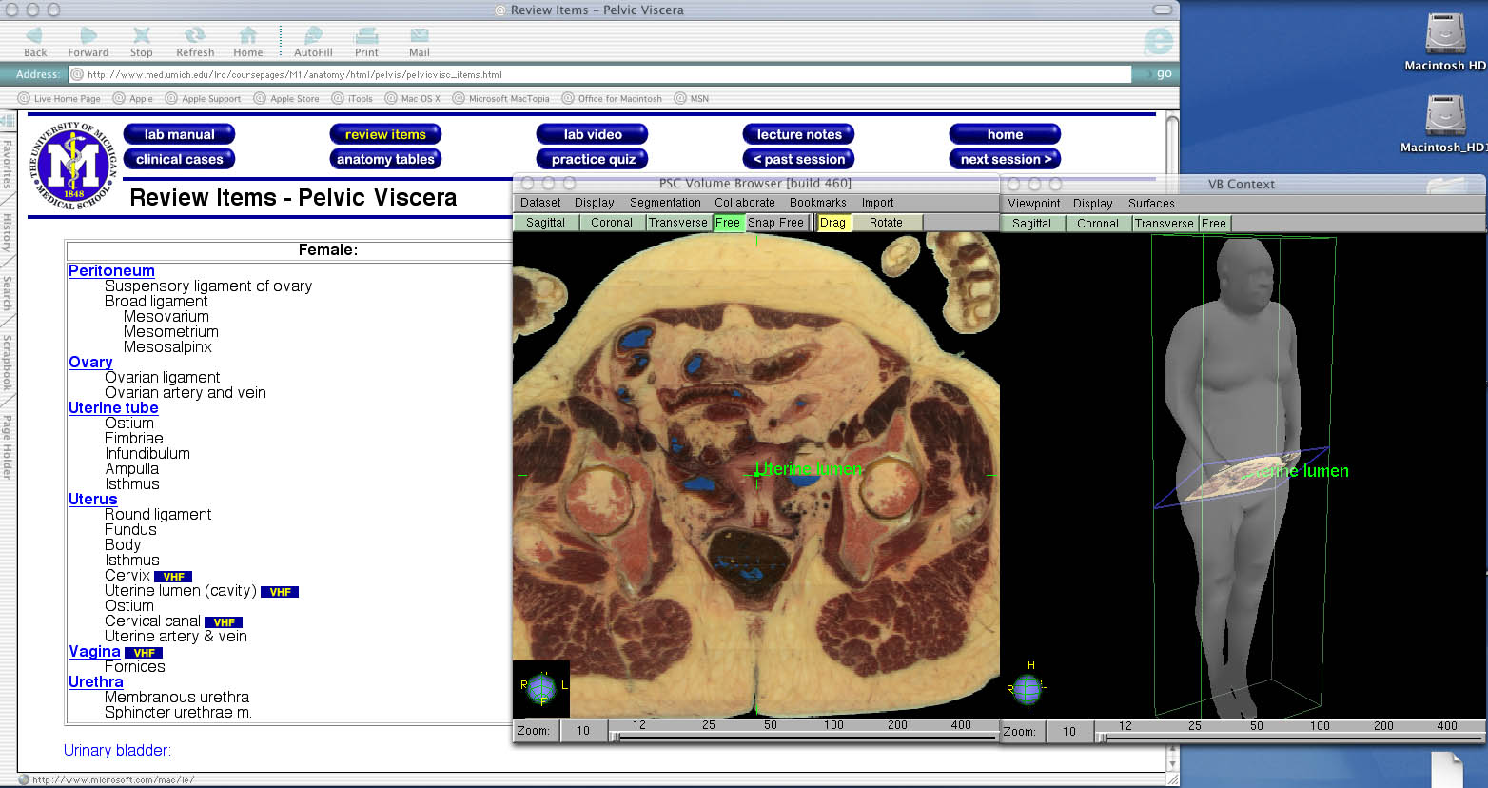
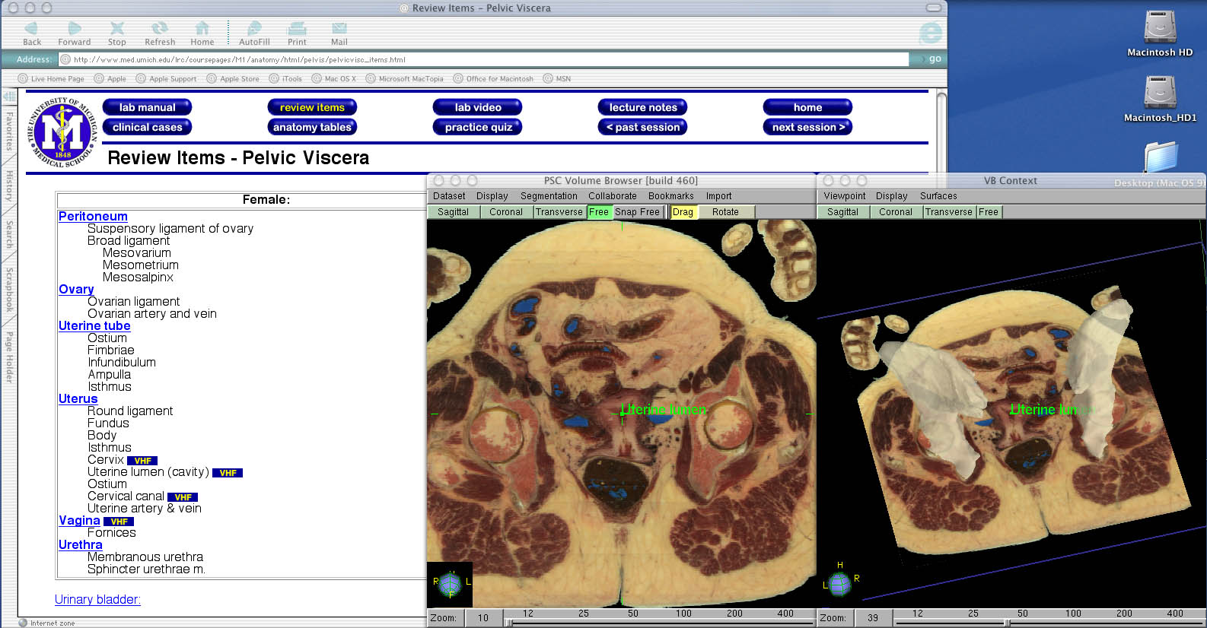

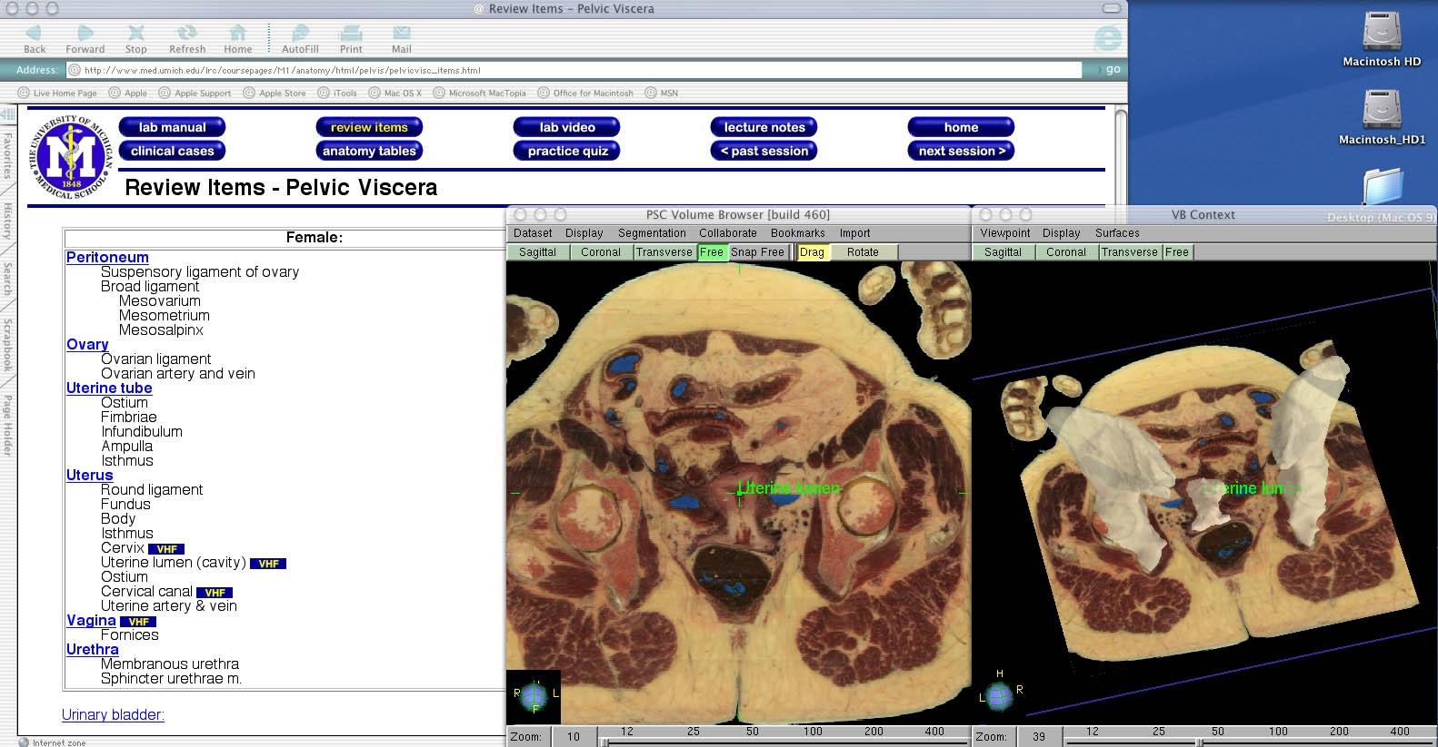
Y3Q2 UMICH UMVHP, G. HENNY QUARTERLY REPORT
Geoffrey C. Henny 7/8/2002

During the last three months I have focused on three main items:

(1) The Collaborative and Scalable Internet2-based Deployment of Just-in-time Training Capability in the End-to-End Context Grant application (The Grant)

As part of ‘the grant’ application process I was involved in communicating with key players to obtain information on their backgrounds and drafting/getting letters of commitment from them. I also wrote and/or edited information on their proposed activities and experience for various drafts of the document.

(2) Special Projects - The MAP project, Content Spinoff, MELS, Interviews

MAP: The University of Michigan Business School and Medical School teamed up to have business school students develop a market opportunity development plan for the UM Visible Human Project (UMVHP). I was the designated UMVHP interface and coach for the students. The project was completed at the end of April 2002 with a report submitted to UMVHP, the Medical School and the Business School recommending a focus on Medical Device Company training and sales programs and Medical School Anatomy courses.
Content Spinoff: UMVHP is seeking to develop new and improved content sources with additional technical and funding partners to complement and extend what is being done with the National Library of Medicine (NLM). I have been looking at this issue during the quarter and prepared a summary approach with some backup presentation material for the Director.

MELS: The Medical Emergency Learning System (MELS) is a project I developed to link UMVHP work with the post 9/11 focus on homeland security and responding to bioterrorism threats. This project is being looked at by a DARPA consultant and will be submitted to other funding sources. Its focus is on integrating UMVHP work on Edgewarp and the Ade browser with the University of California Irvine ALEKS http://www.highed.aleks.com/ interactive learning system, the Canadian Armed Forces Medical Information Gathering System (MIGS), The Carl Berger Concept Map and process monitoring system and a variety of other tools. The objective is to enable users to rapidly identify health problems and respond to them, with very limited initial knowledge.

Interviews: UMVHP is taking on some additional staff to meet its database and systems integration needs for the current grant and expected future grants, including its contract with the Michigan Center for Biological Information (MCBI). I have been part of the team that has been interviewing and evaluating prospects.

(3) New Resource Integration – Hilbelink, USUHS, UM Dental School,
Ferris State University Grand Rapids, Neilsoft

Don Hilbelink Ph.D.: Dr. Hilbelink is Professor of Anatomy at the University of South Florida Medical School and Advisor to Gold Standard Multimedia http://www.gsm.com/ . He is a national leader in the application of computer technology to the study of Anatomy. Don has agreed to spend a six months sabbatical at UMVHP, starting in August 2002, to help extend its research and teaching applications. I have been actively engaged with the director in recruiting Dr. Hilbelink, focusing his activities, and organizing his transition to UMVHP.

USUHS: The Uniformed Services University of the Health Sciences http://www.usuhs.mil/ , is the premiere medical education institution for the US Department of Defense. USUHS is heavily involved in the development and implementation of surgical simulation techniques and the application of virtual reality to medical education. They are a proposed UMVHP subcontractor on the current Grant application and extremely interested in applying UMVHP tools and technology in their work and for future collaborations. I have been working with them to strengthen and focus our relationship, including identifying joint collaboration projects.
UM Dental School: The University of Michigan Dental School is very interested in working with UMVHP as a test bed and on developing research and training tools with a focus on Head and Neck. I have been involved with a number of the Dental school researchers, educators and information technology experts to develop projects that can be of mutual value and can obtain funding.

Ferris State University Grand Rapids: As a result of contacts I made at the Medicine Meets Virtual Reality Conference in January 2002 and subsequent meetings, UMVHP is now using a Ferris team of students to do contouring on Visible Human content. This is part of an effort to reach out across the state of Michigan to collaborate with other institutions and to develop new resources to extend UMVHP work. I have been involved the UMVHP team in developing this collaboration.

Neilsoft: I have been the point – working with the director and Dr. Hilbelink - on developing a relationship with a local software company called Neilsoft, with a large affiliate in India, that is expert in computer aided design tools as well as software development. This company may be used to help enhance various UMVHP tools and content. It may also be a conduit to a fruitful UMVHP international collaboration with Indian Life Science Informatics leaders.
iVOXEL BROWSER: QUARTERLY REPORT: YEAR 3, QUARTER 2
Alex Ade

Progress Report
Efforts this quarter have been directed at improving iVoxel’s three modules. The Volume View module has had numerous interface and display enhancements. The Model View module now supports spline based animations. Optimizations and speed enhancements to the Slice Module have improved download times and rendering capabilities.

Also, the early version of the Web-based Java browser has been updated to read the Pittsburgh Browser’s (VB) XML output file and display its labels.

iVoxel
iVoxel’s Volume View module features enhancements to the Graphical User Interface (GUI). Loading the dataset and switching between render modes and color modes now opens a dialog box with a progress bar and percentage complete updates. An XYZ coordinate axis system is placed at the center of rotation for the arbitrary clip plane set. This allows finer control of the clip planes by showing the orientation and location of each plane in the group (fig. 1 and 2).

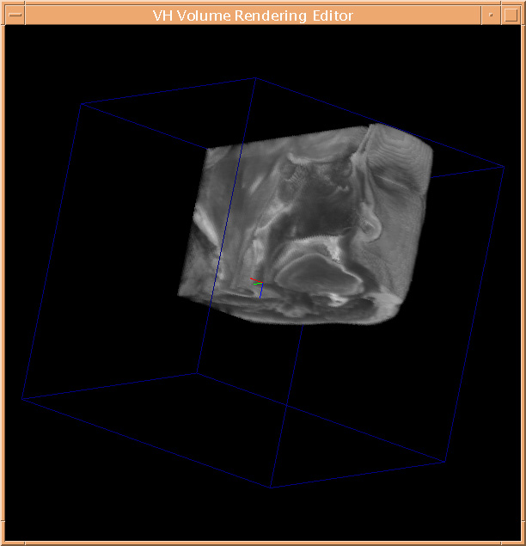
Figure 1: iVoxel's Volume View module. The Volume View module shows a region of the head of the VHP female dataset. A sagittal and transverse clip plane have been added to show the interior of the volume. The XYZ axis (red:x, green:y, and blue:z indicators) is centered on the point of rotation and translocation of the clip plane group.
Figure 2: iVoxel's Volume View module. A single clip plane through the volume at an arbitrary angle showing the nasal sinuses, mandible, and spinal column.

The module now supports multiple color maps. Maps such as intensity are fixed, while others allow user controlled setting of minimum and maximum alpha values (fig. 3).

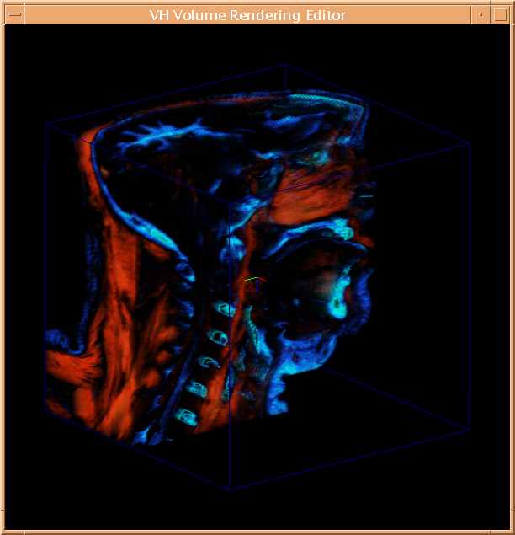
Figure 3: iVoxel's Volume View module. A custom color map for the Volume View highlighting muscle (predominantly brown) and bone (predominantly blue). A sagittal clip plane has been added to show the interior of the volume.

The Volume View module’s stereo support has been improved. Stereo and perspective settings are now read from a configuration file so that single and multi-screen support may be set at runtime. Also, uniform volume scaling is now supported.

iVoxel’s Model View module has been updated to support spline based animations. Spline knots and their associated location, tension, bias, and continuity values are stored in a configuration file. These knots act as keyframes while the path between them is interpolated. The user’s view moves along this path to produce a fly-through animation around the set of models in the display. Multiple paths may be stored in the configuration file.

The Slice View module requests voxel data from the Pittsburgh volume server. These requests have been optimized for faster round-trip times. Also, GUI enhancements to this module include a widget that shows a downsampled slice at all times (fig. 4),

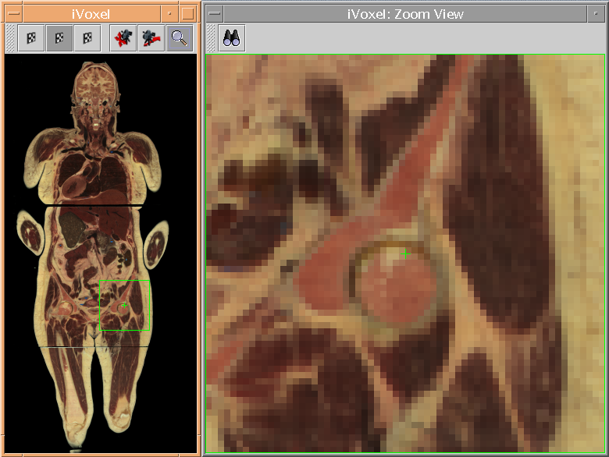
Figure 4: iVoxel's Slice View module. The Slice View module shows a downsampled image to the left with a green region-of-interest (ROI) box. The ROI is shown in the right hand zoom window as data streams from the PSC server to fill in at higher and higher resolutions. This image shows a coronal view of the VHP dataset.

while a zoom window shows high-resolution data. This high-resolution data streams from the server in response to user-controlled mouse movements or warp mode to move to a predetermined location. Multi-resolution data is assembled into images on-the-fly on the client computer.

Java Browser v1.0
The early version 1.0 Java browser has been modified to read VB generated XML files with label and location information. The preview windows are warped to a specified x, y, z location while labels are placed on the high-resolution images.

Future Directions
During year 3, quarter 3, we will continue working to support spline based labels in iVoxel. Also, collaborative functions may be added. With collaboration tools, one copy of the software will act as master while other copies are updated in response to changes in the master copy. Finally, a path authoring tool may be added to the Volume View module so spline paths may be created and edited while visibly represented in the scene.

